For immediate release.

Vanguard Co., Ltd. ANNOUNCES THE LAUNCH OF “ACE PHANTOM”.
Contact:
Vanguard Co., Ltd.

Shinyokohama 3-13-5 Soukyu Building
Kohoku Ward, Yokohama Kanagawa, Japan
222-0033

Tel:
81-045-477-4177

FAX:
81-045-476-4764

Contact Form:
http://www.vgd.co.jp/english/common/inquiry.php

Sub-Head:Vanguard Co., Ltd. has released VR shooting game “Ace Phantom” at 5/18.

Kanagawa,Japan-5/18 – Vanguard Co., Ltd. announces the release of “Ace Phantom”.

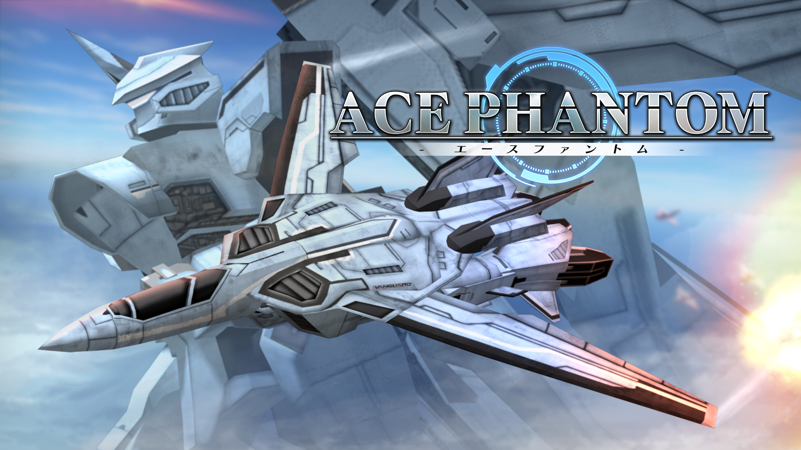

AN AIR FIGHTER , TRANSFORMATION , 360DEGREE BATTLE!!
“ACE PHANTOM” is the VR shooting game developed for Oculus GO.
A player can transform “Air fighter” to “Humanoid Robot” and also can enjoy multiple point of views with special abilities of the craft.

The Japanese animation style air battles would lead all VR gamers from beginners to veteran to exciting battle fields.

Vangurad is also developing “ACE PHANTOM” for mobile(Samsung , Gear VR) , HTC vive and Windows MR

Details
Title：ACE PHANTOM
Categories：VR shooting
Sold in Oculus Store: https://www.oculus.com/experiences/go/1135300939906841/
Release ：May 8th, 2018
Price：$4.99
Platform：Oculus Go
Official Web site：http://www.vgd.co.jp/phantom/index.html
Copy rights: © Vanguard Co., Ltd.

Company Info.
Name : Vanguard Co., Ltd.
CEO : Tomonori Sugiyama
Establishment : October 29th , 1993
Services : Game Planning/Developing/Publishing
Web sit e: http://www.vgd.co.jp/english/

“Creating new joy” is the slogan of us.
We continues to developing many games since the age of NES (Nintendo Entertainment System), and now , we are developing mobile games and also trying VR games to look forward the future of the game.

